**ENGR 3117: Computer-Aided Design Course Outline**

**MEE 3117: Computer-Aided Mechanical Design Course Outline**

**Truss Project Fall 2022**

Design a truss that can support a vertical load of 160 kips and a horizontal load of 130 kips on node two and a 200 kip load on node 4 using the configuration shown below. The material is steel (E=30e6 psi). The cross section is circular. The maximum deformation (nodal displacement) should not exceed 0.01% of the original height or width and the stress should be below yield stress.

You can vary the diameter of the cross section and the height and angles of the members, however your truss but fit within a 16 ft (height) by 30 ft (width) rectangle and have realistic dimensions.

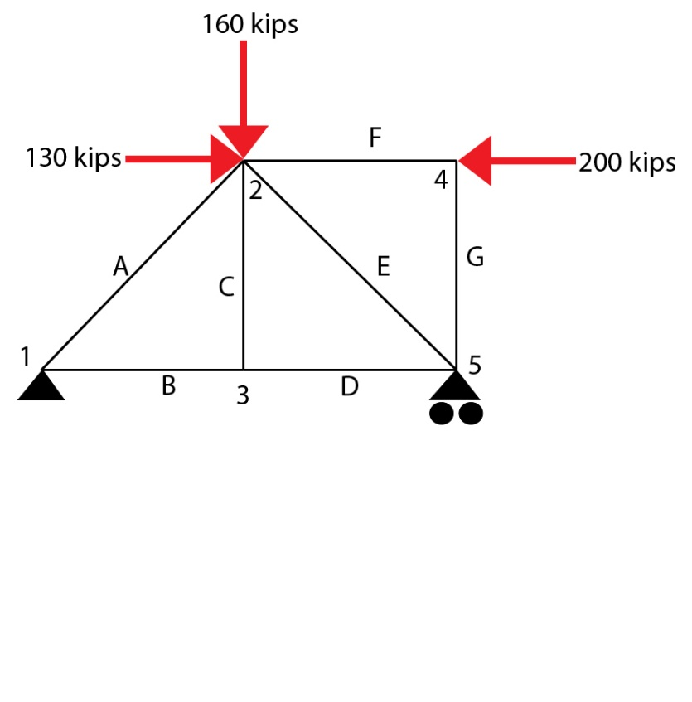

Using Solidworks design your truss then validate your results using traditional statics methods and the direct stiffness method.

You design should be presented in a formatted report that explains the choices you made and includes all iterations.